**Capstone A**

**Assessment Task 1**



**Submitted by:**

Roshan Adhikari: K170784

Gaurav Phuyal: K170766

Harpreet Kaur: K190803

Sajit Magar: K170957

Yashkumar Patel: K191044

**Submitted to:**

**Syed Altaf**

INTRODUCTION

This paper is based on informal documentation of online shopping platform that will be used by Melbourne based Green Apple market. The purpose of this documentation is to examine the scope, requirements, budget, timeline and resources to build an online podium to shop fresh fruits, vegetables. The Green Apple is a local market that sell nearly 85 products that comprises of fruits, vegetables, dairy, juices and poultry. Due to current pandemic, the market facing difficulties to sell products in-person so, there is a solution to transfer the local selling to the online store for Green Apple.

The objectives of the project are to develop a system by using different tools (php, MySQL, html). The report(informal) will discuss the scope statement, key deliverables, WBS, Gantt chart, budget breakdown to develop an online shopping system for the Green Apple.

The scope of the project is to develop a system that contains frontend for user, backend and databases that will perform administrative actions and store the data respectively and the system designed will be feasible and more secure.

There are some limitation or constraints that need to be fulfill. For instance, authentication will be required for login and some constraints on the access of data.

# Company profile

Green apple is the well-known grocery store located in the heart of Melbourne CBD. This store has been providing its quality foods since 2011.

Green Apple Grocery store

12 Bourke Street, Melbourne VIC 3183

Phone: 0451859841

Email: greenapple@gmail.com.au

Fax: 111-342-5400

Annual sales: 5 million

Total employees: 46

Employees at this location: 10

**GREEN APPLE: GO FRESH EVERYDAY**

**Our Vision**

A local leader in distributing foods and veggies – Our vision gives us a sense of destination and direction. It captures our aspiration of being the best in everything we do. Our vision and our values guide the choices and decisions our employees make every day.

**Mission statement**

Our mission is to be the global leader in food supply delivering the quality foods all over the country.

**Our values**

We keep our customer’s choices always upfront. We value, challenge and reward our people.

# Organization chart

Our organizational chart depicts the structure of our organization and relative rank of its parts and positions or jobs. It graphically relates the one official to another. Roshan is the system analyst and several employees work under him. Si milarly, Gaurav is system engineer some employees work under him and same goes for Harpreet and Yash Kumar as well. It can be further clarified from figure given below: -

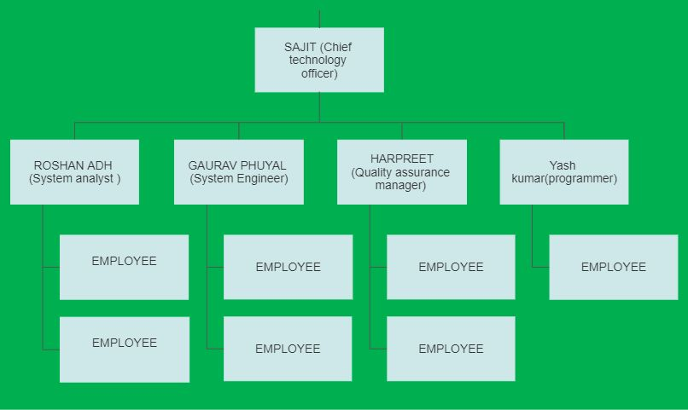

**Fig: Organizational chart**

# Roles and responsibilities

|  |  |  |  |
| --- | --- | --- | --- |
| **NAME** | **ROLE** | **RESPONSIBILITIES** | **CONTACT INFORMATION** |
| Sajit Magar | Chief technology officer | Review all the works and also responsible for day-to-day technology support to ensure that technology-related problems do not interfere the work. | [sajit@ga.com.au](mailto:sajit@ga.com.au) |
| Roshan Adhikari | System analyst | Responsible for using analysis and design techniques to solve business problems using information technology | [roshan@ga.com.au](mailto:roshan@ga.com.au) |
| Gaurav Phuyal | System engineer | Responsible for managing and monitoring all type of installed system. | [gaurav@ga.com.au](mailto:gaurav@ga.com.au) |
| Harpreet Kaur | Quality assurance manager | Responsible for understanding needs of customer to develop effective quality control process. | [Harpreet@ga.com.au](mailto:Harpreet@ga.com.au) |
| Yashkumar | Programmer | Responsible for UI design | [Yashkumar@ga.com.au](mailto:Yashkumar@ga.com.au) |

# Project deliverables

The main functionality that we will be developing in our Green Apple store is our project deliverables. Basically our project has tangible and intangible deliverables which are delivered to our customers. Tangible deliverables discusses the in store functionality regarding goods and intangible deliverables focuses on the services that we will provide.

Our project deliverables are:

* Project scope statement and project charter
* Project Budget
* Work breakdown structure
* Gantt Chart
* Designing system
* Developing Databases
* Developing Website
* Monitoring and controlling system
* Risk management strategy

# Project budget

Project budget explains the total cost required to complete the tasks of any project. In our Green Apple project, the project budget is $161,934.00 which covers all the staff costs, material procurement cost, operating costs and maintenance costs of the system. The importance of project budget is that it will help project manager to determine how much is it going to cost them in order to complete the project and check whether the project is going according to the budget plan or not. Below is the diagram stating the project budget of Green Apple system:-



Work break Down Structure

WBS is the logical framework that provides all the functional deliverables by breaking down into smaller divisions which helps in achieving the targeted goal successfully. It plays a vital role in keeping the project on track (Indelicato, 2009).

The WBS for “Green Apple” project is illustrated below.

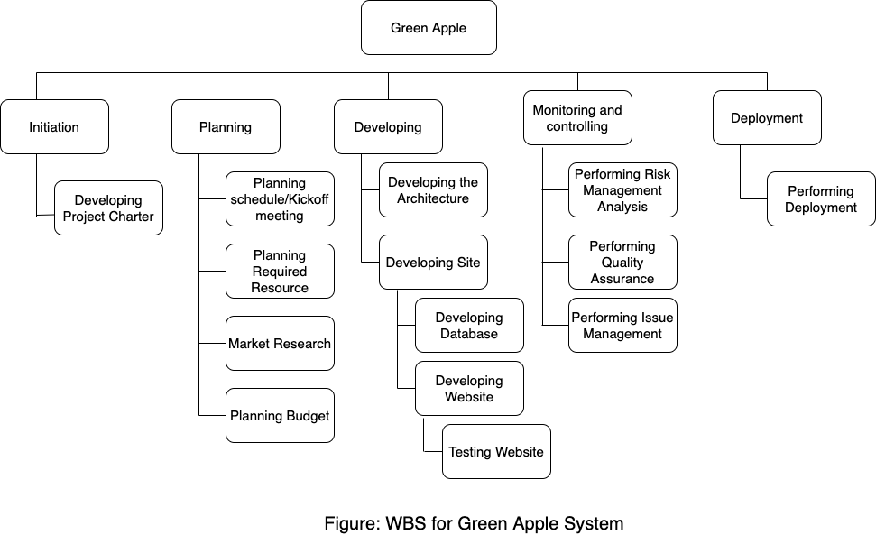

## Project Charter

It provides the overall view of project that helps in delivering the quality project on scheduled time. Moreover, it also illustrates who is responsible for which task along with their start and end date.

|  |
| --- |
| **Project Title:** Green Apple  **Project Start Date:** 15-July-2020 **Project Finish Date:** 15-November-2020 |
| **Budget Information:** The total budget allocated for this project is $161,934. |
| **Project Manager:** Roshan Adhikari, (+61)456789987, roshan@ga.com.au |
| **Project objectives:**  The objectives of the project are to develop a system by using different tools (php, MySQL, html). The report(informal) will discuss the scope statement, key deliverables, WBS, Gantt chart, budget breakdown to develop an online shopping system for the Green Apple. |
| **Approach:**   * Task distribution among the team member creating transparency. * Performing research related to latest trend in market. * Reviewing all the documents related to project on the basis of research performed. * Building system based on the company requirements and research performed. * Launching trial version in small area to collect the feedback from users. * Updating the system based on feedback and launching the system. |

|  |  |  |
| --- | --- | --- |
| **Action Items** | **Assigned to** | **Start date – Due date** |
| Creating Project charter | Roshan Adhikari | 15/07/2020 – 20/07/2020 |
| Planning Budget | Gaurav Phuyal | 20/07/2020 – 22/07/2020 |
| Creating wireframe for system | Gaurav Phuyal /Harpreet Kaur | 23/07/2020 – 15/08/2020 |
| Creating a website | YashKumar/Roshan Adhikari | 16/08/2020 – 15/09/2020 |
| Creating database for system | Sajit Magar | 16/09/2020 – 04/10/2020 |
| Launching trial system | Roshan Adhikari | 05/10/2020 – 25/10/2020 |
| Debugging and improving system based on feedback | Yashkumar/Harpreet Kaur | 26/10/2020 – 10/11/2020 |
| Closing the project by launching the system | Roshan Adhikari | 11/11/2020 - 15/11/2020 |

Note: We will be having team meeting on each due date to discuss about the progress of the project.

# Gantt Chart

Gantt Chart illustrates the graphical view of project.

# Risk Management Plan

As we are setting up the business at online platform to enhance the business, profit and sell, as with the advantage it will also have few potential risks. These are the few serious risks, which can affect our new project and performance of the organisation. These are some potential risks, which we need to take care about it while setting up our new project.

* Risk of new design
* Schedule risk
* Customer dispute and chargebacks
* Ecommerce Intellectual Property

## Project risk register template:

|  |  |  |  |  |  |  |
| --- | --- | --- | --- | --- | --- | --- |
| Risk title | Risk description | Risk category | Date identified | Status | Risk rating | Mitigation method |
| Risk of new design | Risk of new design is that customer might not like our website’s design or format and we might lose customers because of bad design. | People risk | 22/07/2020 | Not yet started | Medium | We can ask regularly customers for their feedback about our service and facilities including online portal. Through their feedback we can make changes accordingly. |
| Project Schedule risk | It is a risk that team members cannot be able to finish the project on the time, it can be possible if project tasks, work and schedule is not arranged properly. | Project risk | 18/07/2020 | Completed | Low | Divide the task and work properly; time management strategy should need to be part of the project. Set up meetings with the team members and keep updated with the work based of timeline. |
| Customer disputes and chargebacks | There are so many customer disputes, which arise regularly from ordering to delivery. Risk would be about the quality, about the delivery, sometimes retailer shipped the wrong product, order billed twice or technical error etc. | Service and business risk | 5/06/2020 | Not yet started | High | Quickly respond to the chargeback notice or complaints, skip charge process until the items are shipped, clear refund and exchange policies. |
| Ecommerce Intellectual property | It is legal term, which refers to industrial property and to copyrights and related issues of our online website. | Business risk | 1/01/2020 | Completed | Medium | Safeguarding of our intellectual property, legally perform an intellectual property audit for our business. |

# References

Indelicato, G., 2009. Book Review: Building a Project Work Breakdown Structure: Visualizing Objectives, Deliverables, Activities, and Schedules. *Project Management Journal*, 40(3), pp.85-85.